Detailed Project Report

AI-Powered Data Analysis System

Revision Number: 1.8

Last date of revision: 22/08/2024

**BY :- VIRAJ TUPE**

Detailed Project Report: AI-Powered Data Analysis System

1. Introduction

The AI-Powered Data Analysis System is a sophisticated tool designed to automate and enhance the process of handling, processing, and analyzing large datasets. It combines a user-friendly API, advanced machine learning models, and a robust backend database to provide seamless data analysis with minimal manual intervention. This report delves into the system’s architecture, components, functionalities, and operational workflow, offering a comprehensive view of its design and implementation.

2. Objective

The primary objective of the AI-Powered Data Analysis System is to streamline the data analysis process by automating key stages from data loading to model evaluation. It aims to:

* Automate Data Loading and Preprocessing: Provide a streamlined process for ingesting and preparing data for analysis.
* Enable Machine Learning Model Building and Evaluation: Offer functionalities to build and assess machine learning models with various algorithms.
* Efficient Data Storage and Management: Utilize MongoDB for effective data management and storage.
* User Accessibility via API: Facilitate user interaction with the system through a RESTful API, enabling easy data analysis requests.

3. System Architecture

The system’s architecture is modular, allowing independent development, testing, and maintenance of its components. It comprises four main modules: Data Processing, Machine Learning, API, and Database. Each module plays a critical role in ensuring the system operates smoothly and efficiently.

Data Processing Module

* Function: Manages the loading and preprocessing of data.
* Components:
  + load_data(file_path): Loads data from a CSV file into a DataFrame, facilitating easy manipulation and analysis.
  + preprocess_data(data, target_column): Cleans the data by handling missing values and splits it into training and testing sets, preparing it for model training.

Machine Learning Module

* Function: Focuses on building and evaluating machine learning models.
* Components:
  + build_model(X_train, y_train): Trains a machine learning model on the provided training data. Currently supports linear regression, with potential for future expansion.
  + evaluate_model(model, X_test, y_test): Assesses the model’s performance using metrics such as Mean Squared Error (MSE) and R-squared, providing insights into the model’s accuracy.

API Module

* Function: Provides a RESTful API for user interaction with the system.
* Components:
  + /analyze: A POST endpoint that accepts data in JSON format and returns analysis results, including model predictions and performance metrics.
  + /upload: Facilitates file uploads for analysis, allowing users to submit CSV files directly to the system.

Database Module

* Function: Handles data storage and management using MongoDB.
* Components:
  + connect_to_mongo(db_name): Establishes a connection to the specified MongoDB database, ensuring reliable data storage.
  + insert_data(db, collection_name, data): Inserts processed data into the designated MongoDB collection for efficient data management.

4. System Workflow

The system operates through a well-defined workflow, ensuring that each step of the data analysis process is handled efficiently:

* Data Loading: Users upload a CSV file containing the dataset through the /upload API endpoint. The file is processed using the load_data() function to create a DataFrame.
* Data Preprocessing: The preprocess_data() function is triggered to clean and prepare the data. This includes handling missing values and splitting the dataset into training and testing sets.
* Model Building: The build_model() function uses the training data to train a machine learning model. This model is then used for making predictions on the test data.
* Model Evaluation: The evaluate_model() function evaluates the model’s performance using test data. Metrics such as MSE and R-squared are calculated to gauge the model’s accuracy.
* Result Delivery: Users can request the analysis results via the /analyze API endpoint. The system responds with performance metrics and model predictions in JSON format.

5. Technologies Used

The system leverages a range of technologies to ensure robust functionality and performance:

* Python: The primary programming language for developing the Data Processing and Machine Learning modules, chosen for its extensive libraries and ease of use.
* Flask: A lightweight framework for building the RESTful API, enabling smooth interaction between the user and the system.
* MongoDB: A NoSQL database used for storing and managing data efficiently, chosen for its scalability and flexibility.
* Pandas: Utilized for data manipulation and analysis, providing powerful tools for data handling.
* Scikit-learn: Employed for machine learning model development and evaluation, offering a wide range of algorithms and tools for model training and assessment.

6. Error Handling and Logging

Robust error handling and logging mechanisms are integral to the system’s reliability. Key aspects include:

* Error Handling: The system includes error-checking routines to manage issues such as file loading errors, database connection failures, and model evaluation problems.
* Logging: Comprehensive logging captures errors and system events, providing valuable insights for debugging and ensuring transparency in the system’s operations.

7. Future Enhancements

Several potential enhancements could improve the system’s functionality and user experience:

* Algorithm Expansion: Integration of additional machine learning algorithms, such as Decision Trees, Random Forest, and Neural Networks, to offer more diverse analytical capabilities.
* Enhanced User Interface: Development of a web-based user interface to make the system more accessible and user-friendly for non-technical users.
* Real-Time Data Processing: Implementation of real-time data processing capabilities to handle dynamic and streaming data more effectively.
* Scalability: Optimization of the system to handle larger datasets and support concurrent user requests, ensuring performance and reliability as usage grows.

8. Conclusion

The AI-Powered Data Analysis System delivers a comprehensive solution for automating data analysis processes. Its integration of data processing, machine learning, and API functionalities into a modular architecture provides a versatile tool for data-driven applications. The system’s design facilitates easy maintenance and expansion, positioning it as a valuable asset for users seeking efficient and automated data analysis solutions.

Appendices

* Appendix A: Code Snippets - Provide relevant code snippets for key functions and modules.
* Appendix B: Sample Data - Include sample datasets used for testing and demonstration purposes.
* Appendix C: API Documentation - Detailed documentation of API endpoints, including request and response formats.

References

* List of References - Cite any books, articles, or online resources referred to during the project.

This expanded report provides a thorough overview of the AI-Powered Data Analysis System, ensuring a clear understanding of its design, functionality, and future potential.

**6. System Architecture Diagram**

The system architecture for the AI-powered data analysis platform includes several key modules that interact to provide a seamless user experience. Below is an overview of the architecture:

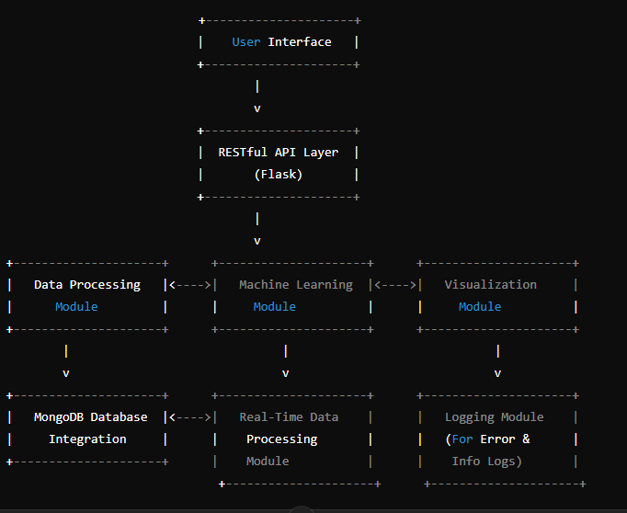

**7. Wireframe Documentation**

**1. API Endpoint Layout:**

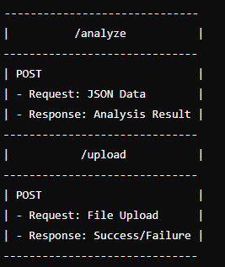

2. User Interface Layout (if developed as a web app):

